Part B

Identify True or False:

1. ls is used to list files and directories in a directory. True



1. mv is used to move files and directories. True

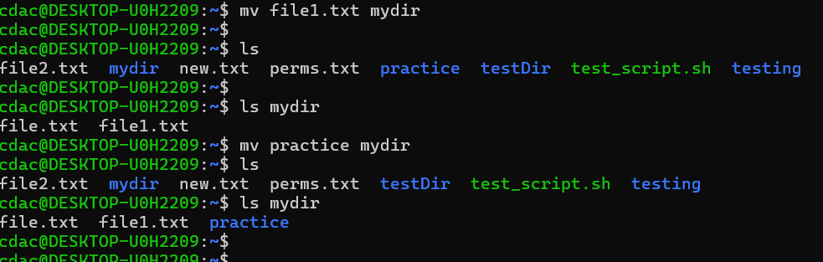

1. cd is used to copy files and directories. False

It is used to change directories.

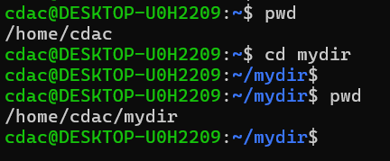

1. pwd stands for "print working directory" and displays the current directory. True

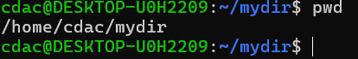

1. grep is used to search for patterns in files. True

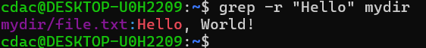

1. chmod 755 file.txt gives read, write, and execute permissions to the owner, and read and execute permissions to group and others. True

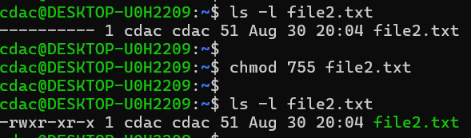

1. mkdir -p directory1/directory2 creates nested directories, creating directory2 inside directory1 if directory1 does not exist. True

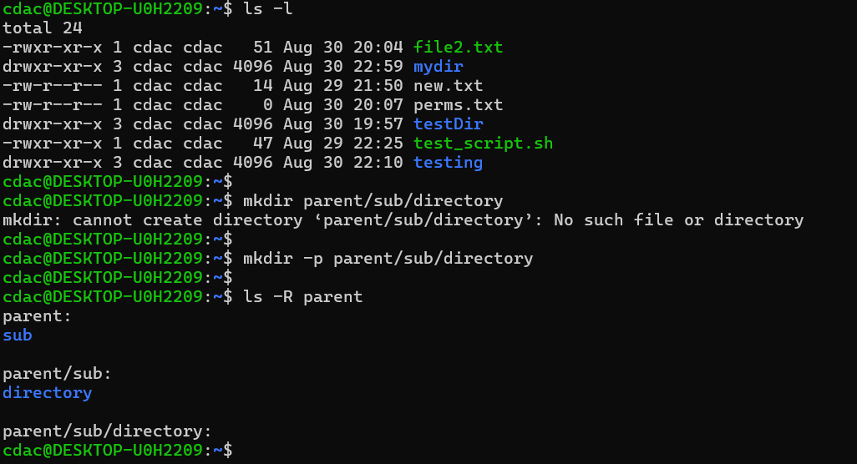

1. rm -rf file.txt deletes a file forcefully without confirmation. True

-f option is used to delete a file forcefully without confirmation even if there is no write permission. -r is used to delete entire directories

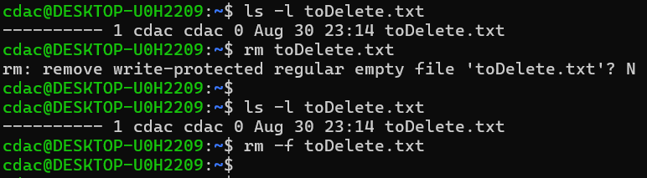

Identify the Incorrect commands:

1. chmodx is used to change file permissions.

* Incorrect. It should be chmod.

1. cpy is used to copy files and directories.

* Incorrect. It should be cp.

1. mkfile is used to create a new file

* Incorrect. To create a new file we can use touch, cat (by redirection >), nano, etc.

1. catx is used to concatenate files.

* Incorrect. It should be cat.

1. rn is used to rename files.

* Incorrect. To rename files, we use mv (move) command.